The United States from the Colonial Era to the Civil War
Course Site

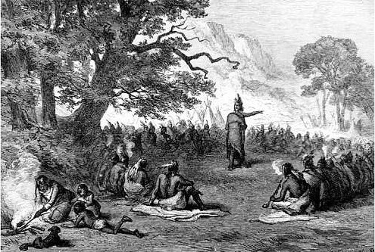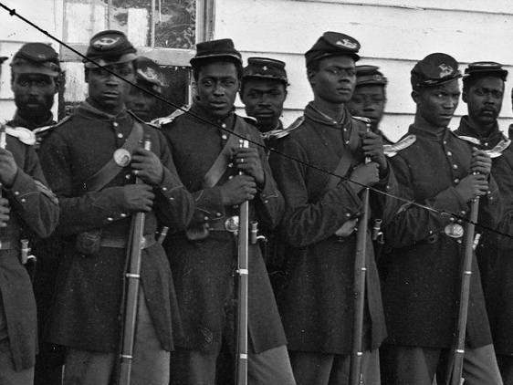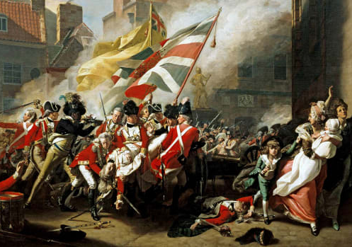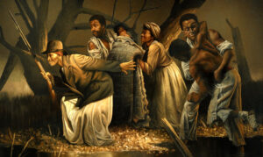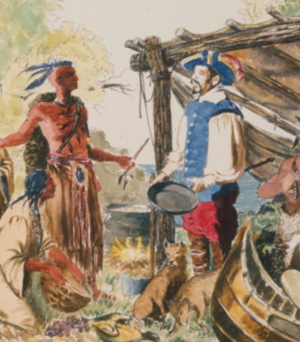

Course Description:

This course serves as a general introduction to the main events, themes, and movements in American history from colonization through the Civil War. It seeks to identify and explore the transformative social, cultural, and political moments of this long historical period. Thus, the course examines European contact, conflict, cooperation with and colonization of indigenous peoples; the transatlantic slave trade; coercive labor forms and slave revolts in the American Colonies and the United States; the context that led to, and consequences that came from the American Revolution; Native removal, genocide and resistance; western conquest justified by the logic of Manifest Destiny; immigrant and class conflict in the colonies and early republic; a redefinition of household and gender roles in early American society; the long road to Civil War. Students will also develop skills such as writing for a humanities audience, critical reading of primary and secondary sources, and argument-based discussion. In sum, this course introduces students to a wide variety of analytical tools and approaches to better understand the settlement of North America and the founding of the United States.

Prerequisites

No prerequisites for this course

Learning Outcomes

Upon successful completion of this course, students will be able to:
- Identify and discuss the importance of contact and conquest, colonial foundations, revolution and Constitution, immigration, geographic expansion, experiences of Native peoples, role of women, slavery and African American experiences and the sectional crisis leading to the Civil War
- Understand how conceptions of freedom, equality, and opportunity changed from the founding of colonies through the Civil War.
- Identify and apply the key historical concepts of change-over-time, cause-and-effect, agency, historical empathy, and continuity and discontinuity, and recognize how these concepts are employed in the historical method
- Analyze and interpret primary sources with attention to audience, authorship, and context
- Recognize some of the ways in which historians have conflicting interpretations of the past
- Recognize how and why U.S. history has been taught differently to different generations and communities.
- Produce a paper with a clear thesis and appropriate citations based on strong evidence drawn from historical sources

Course Resources

Course Textbook

The American Yawp: A Massively Collaborative Open U.S. History Textbook (Stanford University Press, Last Updated January 2022)

Primary Resources

The American Yawp Reader: A Documentary Companion to the American Yawp (Stanford University Press, Last Updated January 2022)

Additional Materials

Corbett, P. Scott, Volker Janssen, John M. Lund, Todd Pfannestiel, Sylvie Waskiewicz, Paul Vickery, U.S. History,(OpenStax, Last Updated 2021)

Finesurrey, Samuel Case Studies in the History of U.S. Empire and Society (OER Commons, Last Updated 2022)

_________, “Conducting Interviews,” in Ethnographies of Work, edited by Alia R. Tyler-Mullings, Mary Gotta, Ryan Coughlan, (Manifold, 2019).
Holloway, Kali “American History Is Getting Whitewashed, Again” (The Nation, October 2, 2020)

Course Assignments and Grading

A | 100-94 | 4.0 | Outstanding | C | 76-73 | 2.0 | Satisfactory
A- | 93-90 | 3.7 | Excellent | C- | 72-69 | 1.7 | Less than Satisfactory
B+ | 89-87 | 3.3 | Very Good | D+ | 69-67 | 1.3 | Poor but Passing
B | 86-83 | 3.0 | Good | D | 67-60 | 1.0 | Minimum for Credit
B- | 82-80 | 2.7 | Above Average | F | 59 -0 | 0.0 | Failure
C+ | 79-77 | 2.3 | Average

Weekly Assignments (30 Percent): Every week there will be a set of graded assignments on the readings due Sunday at midnight. You will submit your notes on the assigned materials and write a paragraph response to each discussion question.

Oral History Project (20 Percent): You and each of your peers will interview an elder from your family or community about how they were taught the events we’ll be covering in this course. You and your classmates will create the questions, choose your interviewees, conduct the interviews, collect photos and consent forms, before creating a transcript of the interview.

Final Paper (25 Percent): You will submit a final paper where you look at how a certain event from the class of your choosing has been taught overtime. Using your own interview and those of your peers, as well as old textbooks and primary sources, you will analyze how and why an event was explained differently in the past when compared to how we approached the historic event, theme or movement this semester.

Final Exam (20 Percent): The final exam will consist of short answers and a single essay.

Participation (10 Percent): You are expected to participate in class discussion. If you are late to class, it will negatively impact your participation grade.

Course Schedule
Week | Topic | Assignment | Due
1 | Class One: Introduction/Before Columbus  Class Two: 16th and 17th Century Imperial Competition and Colonization in North America | - The American Yawp:  Chapter One (Sections I-III: Introduction, The First Americans & European Expansion)  Chapter Two (Colliding Cultures)  - The American Yawp Reader:  “Native American Creation Stories” Chapter 1 | - Reading Notes  - Discussion Response
2 | Class Three: Early Coercive Labor Systems and the Birth of a Slave Society  Class Four: Slave Revolts and Solidarities in the British Colonies | - The American Yawp:  Chapter Four (Section III: Slavery, Anti-Slavery & Atlantic Exchange)  - Case Studies in the History of U.S. Empire and Society:  “The John Punch Case (1640)”  - The American Yawp Reader:  “Olaudah Equiano describes the Middle Passage, (1789)” & “Rose Davis is Sentenced to A Life of Slavery (1715),” Chapter 3 | - Reading Notes  - Discussion Response
3 | Class Five: Social Control in the American Colonies  Class Seven: 18th Century Imperial Competition and Colonization in North America | - The American Yawp:  Chapter Four (Section V: Seven Years’ War)  - The American Yawp Reader  “Accusations of Witchcraft, 1692 and 1706,” Chapter 4 | - Reading Notes  - Discussion Response
4 | Class Six: Native Genocide and Resistance in Colonial America  Class Eight: Imperial Crisis | - The American Yawp:  Chapter Four (Section VI: Pontiac’s War)  - U.S. History,  Chapter Four (Section V: Wars for Empire)  - The American Yawp Reader  “Pontiac Calls for War (1763)” & “Alibamo Mingo, Choctaw Leader reflects on British and French (1765),” Chapter 4 | - Reading Notes  - Discussion Response
5 | Class Nine: Social Context of the American Revolution  Class Ten: American Revolution | - The American Yawp:  Chapter Four (Section V: The War for Independence)  - The American Yawp Reader:  “Boston King recalls fighting for British and Securing his Freedom (1798),” Chapter 5  “Creek Headman Alexander McGillivray Seeks to Build Alliance with Spain (1785), Chapter 6  - Our Revolution:  “The Argument Against Slavery and the Somerset Case (1772)”  - U.S. History:  “Revolutionary Limits: Native Americans” | - Reading Notes  - Discussion Response
6 | Class Eleven: Federal Constitution  Class Twelve: Defining Social Hierarchies, Citizenship and Voting Rights in a New Nation | - The American Yawp:  Chapter Four (Section VI: The Consequences of the American Revolution)  Chapter Five (Sections I-V, VII & IX: Introduction, Shay’s Rebellion, The Constitutional Convention, Ratifying the Constitution, Rights and Compromises, The Whiskey Rebellion and Jay’s Treaty, Religious Freedom)  Chapter Six (Section VI, The War of 1812)  Chapter Seven (Section IV & V: Changes in Labor Organizing & Changes in Gender Roles and Family Life)  Chapter Ten (Section VI: Women’s Rights in Antebellum America).  - The American Yawp Reader:  “Abigail and John Adams converse on Women’s Rights (1776),” Chapter 5  “What to the Slave is the Fourth of July,” Chapter 9  “Sarah Grimké Calls for Women’s Rights (1838)” Chapter 10 | - Reading Notes  - Discussion Response
7 | Class Thirteen: Introduction to Oral History Project – “Ways of Remembering America’s Foundation”  Class Fourteen: Western Expansion and Native Genocide as Policy in the early U.S. Republic | - The American Yawp:  Chapter Six (Section V: Native American Power, and the United States)  Chapter Twelve (Section II: Antebellum Western Migration).  - The American Yawp Reader:  “A Confederation of Native Peoples Seek Peace with the United States (1786)” Chapter 6  “Tecumseh Calls for Native American Resistance (1810)” Chapter 7  “Cherokee Petition Protesting Removal, 1836” Chapter 12  - Case Studies in the History of U.S. Empire and Society:  “The Trail of Tears”  - Ethnographies of Work:  “Conducting Interviews” | - Reading Notes  - Discussion Response
8 | Class Fifteen: Southern and Northern Slavery and Resistance in the U.S. Republic  Class Sixteen: Finalizing Oral History Project – “Ways of Remembering America’s Foundation” | - The American Yawp:  Chapter Six, (Section II: Free and Enslaved Black Americans and the Challenge to Slavery)  Chapter Seven (Section III: The Decline of Northern Slavery and the Rise of the Cotton Kingdom)  Chapter Ten (Section I & V: Introduction & Antislavery and Abolition)  Chapter Eleven (The Cotton Revolution)  - The American Yawp Reader:  “David Walker’s Appeal to the Colored Citizens of the World” (1829), Chapter 10  “Nat Turner Explains Southampton Rebellion” (1831), Chapter 11  “Stories from the Underground Railroad (1855-1856)” Chapter 13 | - Reading Notes  - Discussion Response  - Oral History Questions and Edits Due
9 | Class Seventeen: Manifest Destiny and the Mexican American War  Class Eighteen: Myth Making of America’s Foundation | - The American Yawp: Chapter Twelve (Section I, IV-VI: Introduction, Texas, Mexico and the United States, Manifest Destiny and the Gold Rush & The Monroe Doctrine and Manifest Destiny)  - The American Yawp Reader:  “Wyandotte Woman Describes Tension Over Slavery (1849)” Chapter 12  - Case Studies in the History of U.S. Empire and Society:  “Manifest Destiny”  - The Nation:  “American History Is Getting Whitewashed, Again” | - Reading Notes  - Discussion Response  - Oral History Projects Due
10 | Class Nineteen: Immigration and Industrialization  Class Twenty: The Sectional Crisis | - The American Yawp:  Chapter Seven (Section VI: The Rise of Industrial Labor in Antebellum America)  Chapter Eight (Section III-IV & X-XI: The Missouri Crisis, The Rise of Andrew Jackson & Anti-Mason, Anti-Immigrant and the Whig Coalition, Race and Jacksonian Democracy)  Chapter Thirteen (The Sectional Crisis)  - The American Yawp Reader:  “Maria Steward Bemoans the Consequences of Racism (1832)” & “Harriet H. Robinson Remembers as Mill Workers Strike (1836),” Chapter 7  “Samuel Morse Fears a Catholic Conspiracy (1835)”, Chapter 9 | - Reading Notes  - Discussion Response
11 | Class Twenty-One: The Civil War  Class Twenty-Two: State of the Nation 1865 | - The American Yawp:  Chapter Fourteen (The Civil War)  - The American Yawp Reader:  “1860 Republican Party Platform (1860)” Chapter 13  “William Henry Singleton, A Formerly Enslaved Man, Recalls Fighting for the Union (1922),” Chapter 14 | - Reading Notes  - Discussion Response
12 | Class Twenty-Three: Final Review |  | - Final Paper Due
 | Last day of Class
 | Final Exams

Much of this course was derived respectively from Noah L. Gelfand’s & Duangkamol Tantirungkij History 151 courses taught at Hunter College in Fall 2021.

